
Dear Elon Musk & Company.
My name is Evan, and I am delivering to you
🚨 SPECIAL OPERATIONS REPORT #4 🚨
from OPERATION $YING $YANG
@@ MAGIC EYES ONLY
0400 RCAF Z MAR 24 2026

👽🤠 YEEE HAW LIL BUDDY!
1 TW of compute!!! That’s insaine!-@@ Congrats to everyone at the X team & Grok. AI has contributed to it’s own advancement at this point as I have no doubt in Grok’s assistance in planning this new venture.

I have made heavy use of the AI in planning my own company; including using Grok to genertate all the travel destination paragraphs for each location listed on my website. They say you arent official until you have a website. Well here is mine:

https://www.prairielanes.ca/destinations.html
Welcome to the DESTINATION 2030 MOONSHOT PROJECT! (The Alberta “Disneyland” Project). Yes I know! Copyright infringement (regardless everyone is just going to call it the “Canada Disneyland Project”). It took me 10 WHOLE MONTHS to finally name this company! Apparently naming companies is the most stressful thing the company ever experiences.

So without further adue after months of speclation and rumors, I have decided to name the company PRAIRIE LANES CORP. (Not to be confused with the other proposed high speed train network Prairie Link). *sigh*

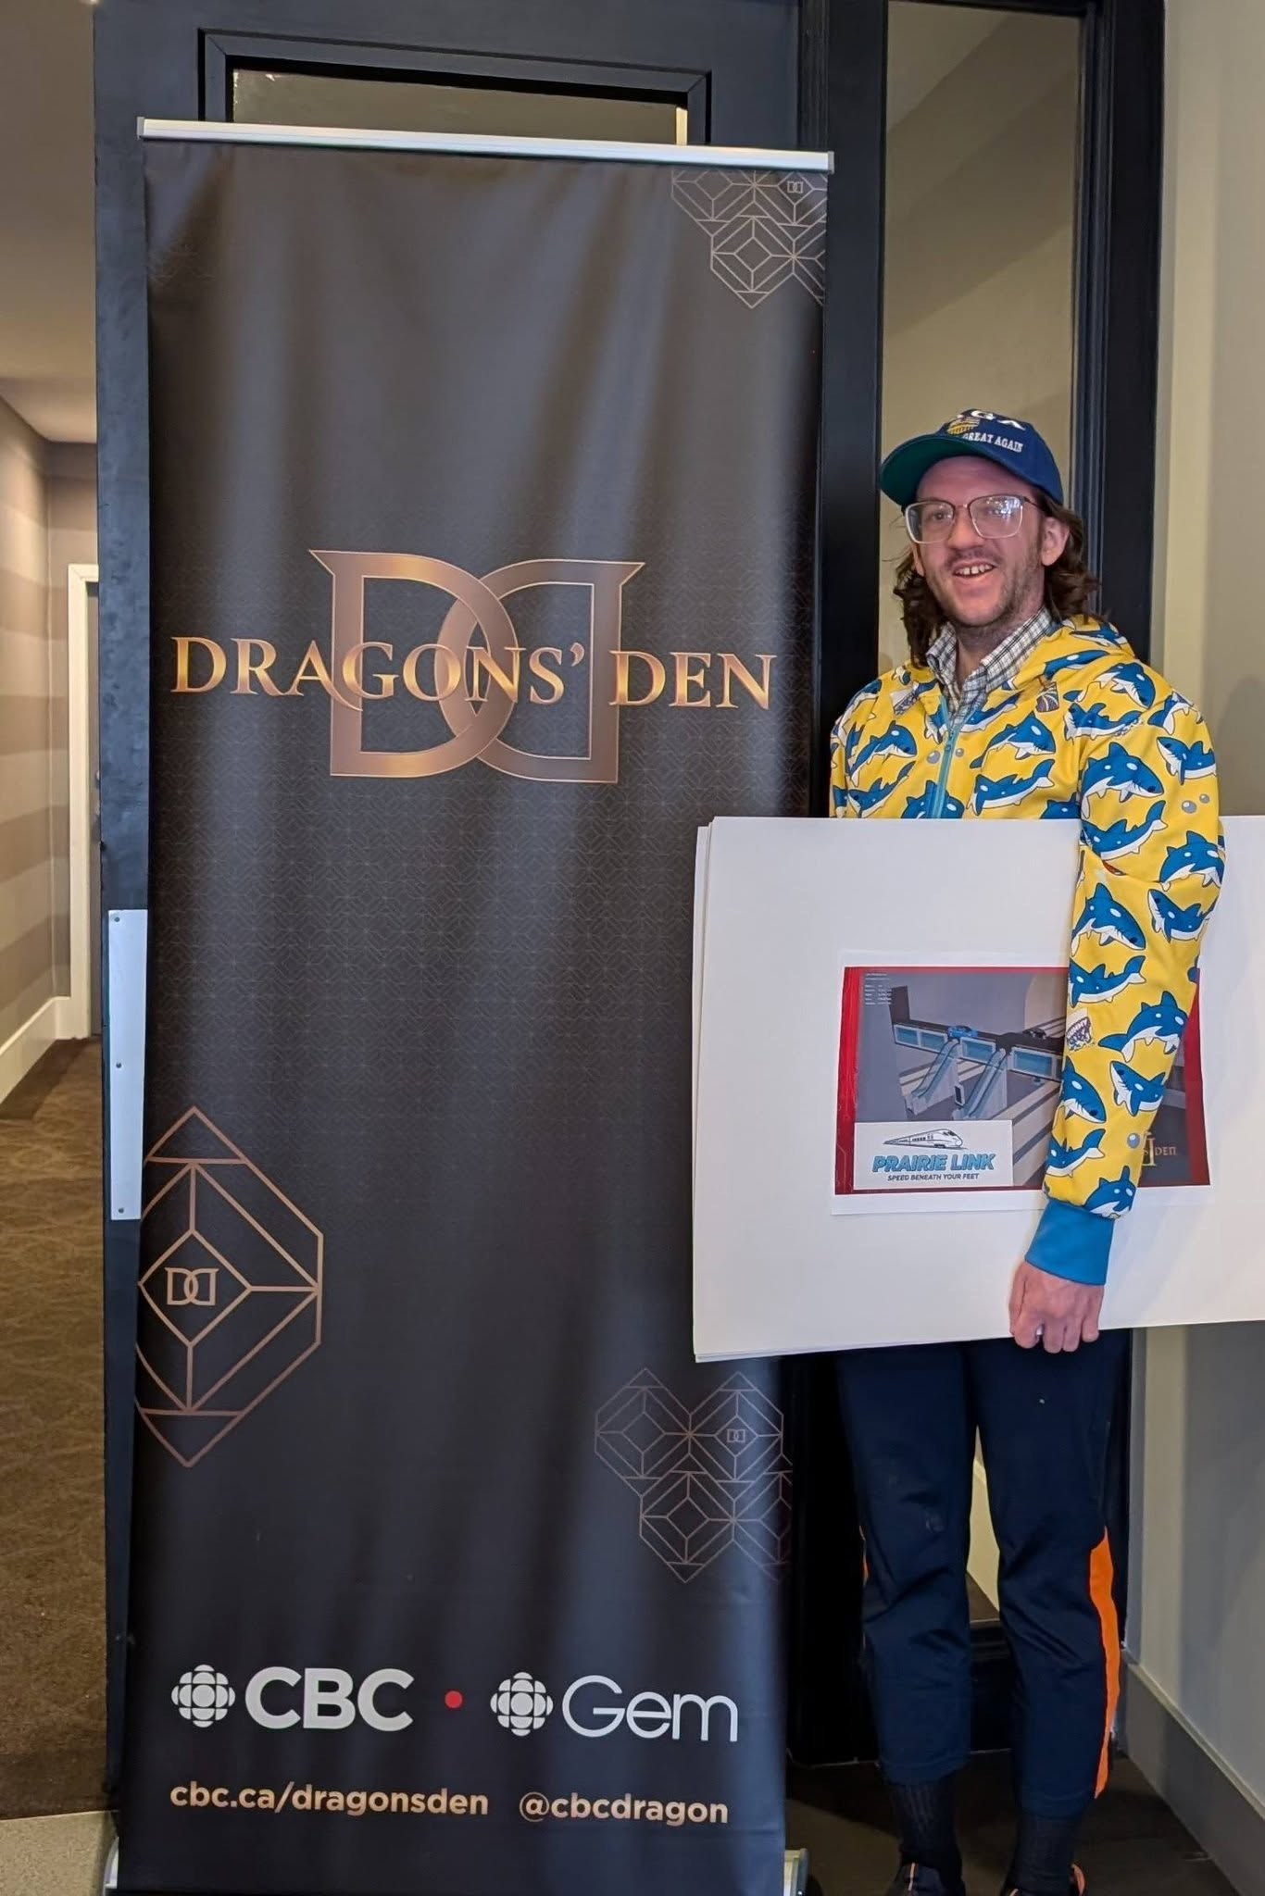

I’ve auditioned now in Calgary to appear on the Dragons Den. A famous Canadian TV show where anyone with a business (or an idea for a business) can apply to pitch their ideas on national television. That was 3 weeks ago; Ive already moved onto other things as I only have 3 weeks left before I know if I will appear on the show.

In the past 3 weeks of work, these are the things I have been able to accomplish for my company with the help of Grok:
- Hired a Virtual Reality developer to produce a VR experience for the new transit system.
- Hired a local DJ to produce all the music for the facility & announcements for arrivals and departures.
- Hired a graphic artist to produce all the signage, logos & ads for the facility.
- I raised $100 crowdfunding locals. Giving my company a 6.4 Million dollar evaluation on paper. (With help from the AI and some simple but clever math calculations) I grew my company from a $2 investment into a 6 million dollar overnight empire.
- I CREATED the world’s fastest growing company: Praire Lanes!
- I networked with a local man who previously ran his own transportation business, and have given him an informal offer for the position of Vice President.
- I have found an old high school friend who would be suitable to be my social media manager/producer as I expect to edocument 100% of the process for a new YouTube channel. Yet another potential source of revenue for the company.
- I have found an old high school friend who would be suitable for a private security detail.
- I sourced producers of high speed Mag Lev trains in China.
- I have sourced producers of Tunnel Boring Machines (TBM) in America, China, and Japan.
- I have sourced over 400 acres of strategic land across the Alberta landscape.
- I have contacted numerous real estate agents and have received zoning maps, by-law regulations and information about the area.
- MOST of the land sourced is on some township road in the middle of nowhere and cant even be found by searching Google Maps. Thank God for Grok; the AI can search through miles of endless government documents and by law zoning information to get precise coordinates for a plot of empty land for sale.
- The communities of Red Deer, Didsbury, and Olds were publicly informed of the project.
- I programmed a calculator into Excel to calculate the cost of construction (required for my pitch material). The project budget.
- I produced a 13 slide powerpoint as a pitch deck.
- I spoke with the local utility commisions to get details on power consumption, and hooking up to the electrical grid.
- Ive consulted an environmental expert who would be willing to join the team. Provided the company pays for medical expenses.
- Ive created an inventory of stock for the company.
- I created a Discord community to manage every aspect of the project as the Project Manager.
- Ive consulted with local construction & production firms who need engineering level diagrams to get quotes as the next step.
- Ive contacted engineering firms in Calgary to see whats available to turn my diagrams into professionally drawn blue prints.
- Ive sent inquiries to govenrment officials regarding all the required permiting & costs involved.
- I spent over 100 hours modeling a to-scale layout of the tunnel system in 3D.
- I toured local office spaces designed for businesses to rent out. Scouted as a likely location for Headquarters in Didsbury.
- I consulted my legal team and got a $30K quote from them on filing patents + another 2-5K in legal fees for setting up and structing the company.
- I have met with my investors and kept them in the loop about the progress.

👽🤠 Welcome to the greatest story every told! YEEE HAW
But I’m not telling $YOU unless you invest in me FIRST!

I am officially setting the fuse on a technological arms race! First contractor to produce for me a 20M wide drill bit that can drill beneath open farmland acrosss Alberta gets the contract. For $10 Billion CAD worth of tunnelling operations. Whether that’s Boring Company or someone else time will tell.
Send an email to techskullgames@gmail.com
To get the full project specifications required for the Canadian Hyperloop Project.

PS: If they call you crazy, its because they call me crazy too. 1TW. Really?
SAV 38
DEL 32
DEL TYPOS
DEL 0
<<>>

👽 👽
TRIST MAGICTIS
🕸️ s.

You can’t claim ignorance or say that you didn’t know.
3 2 1 GO!
ASC 28

https://youtu.be/DjP_HmgwENw
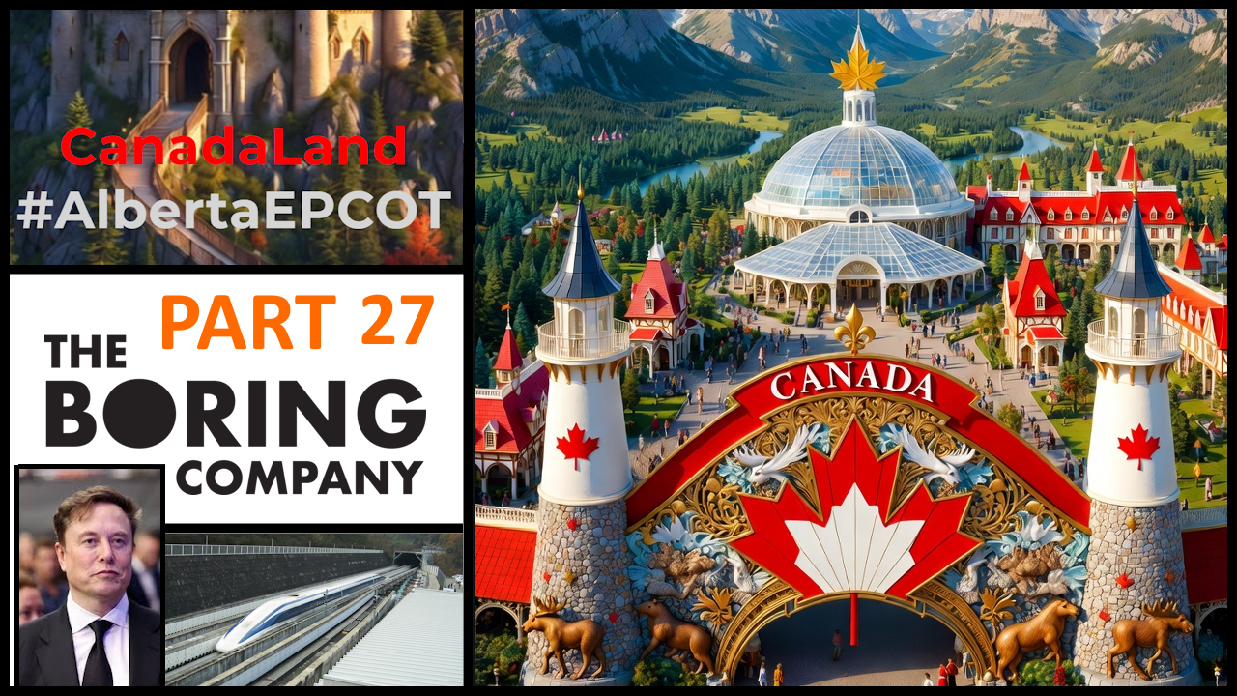
https://youtu.be/8h792LQWC50


